Ideation Phase
Define the Problem Statements

Date | 26 September 2026
Team ID | 6ab229b877181cf94a22636a
Project Name | AI WeatherWise
Maximum Marks | 2 Marks

Customer Problem Statement Template:
The customer problem statement helps identify the problems faced by users when accessing weather information and understanding weather conditions. AI WeatherWise aims to address these problems by providing weather information
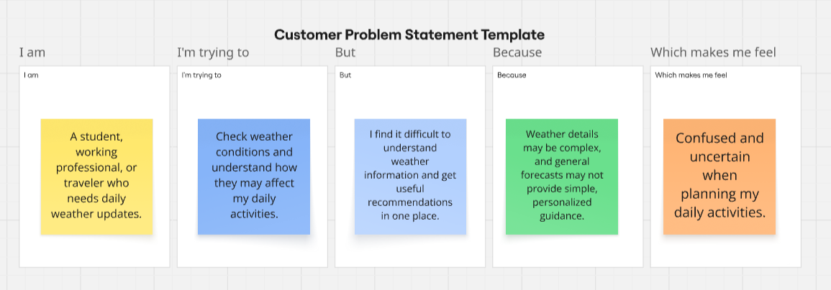
Reference: https://miro.com/templates/customer-problem-statement/

Applied to AI WeatherWise:
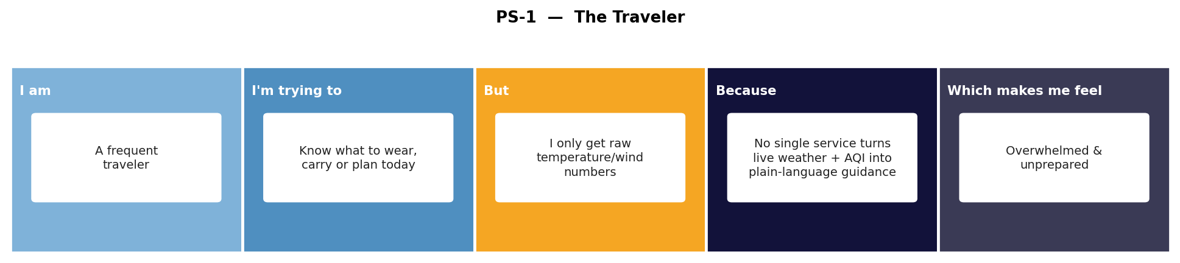

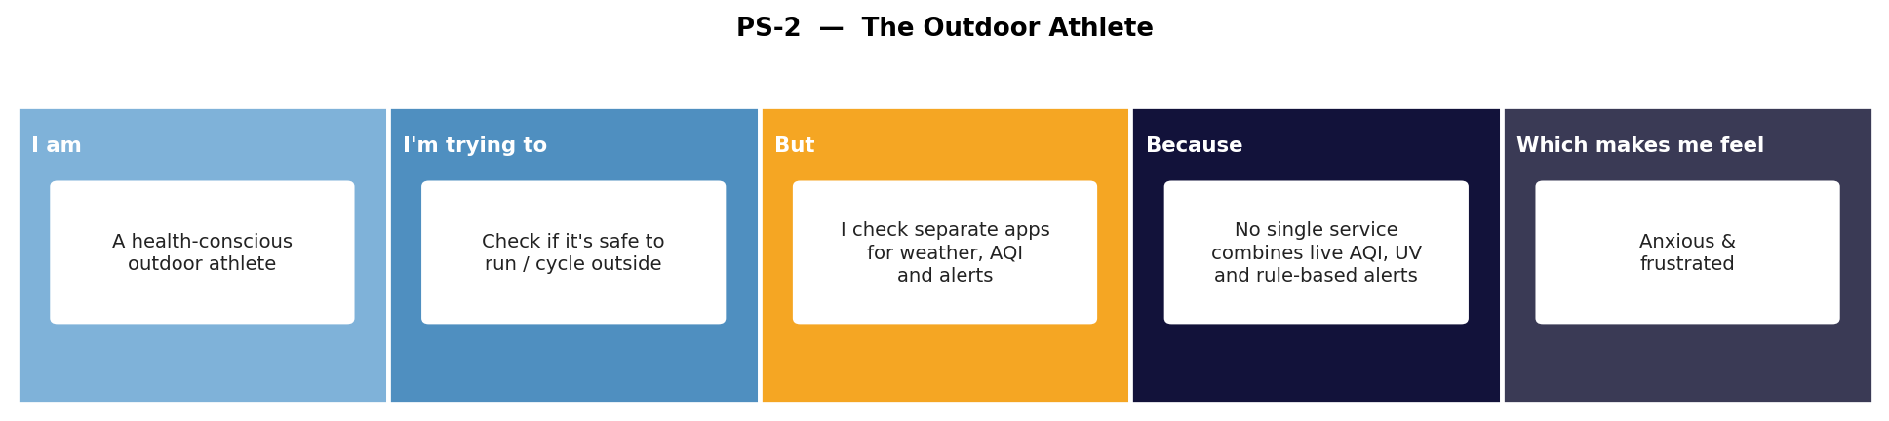
Problem Statement (PS) | I am (Customer) | I’m trying to | But | Because | Which makes me feel
PS-1 | A frequent traveler | know what to wear, carry, or plan for today without digging through raw weather numbers | I only get raw temperature, wind and rain figures, not activity-ready guidance | there is no single service that turns live weather and air-quality data into personalized, plain-language guidance for the places I'm visiting | overwhelmed and unprepared for the day ahead
PS-2 | A health-conscious outdoor athlete (runner/cyclist) | check whether it's safe to exercise outside today | I have to check separate apps for weather, air quality (AQI) and safety alerts | there is no single, authenticated service that combines live AQI, UV index and rule-based severe-condition alerts with my saved favorite locations | anxious about my health and frustrated switching between apps

